Intent-Aware Encryption: Context-Driven Security for Adaptive Communication Systems

Table of Contents:
- Abstract
- Introduction
  - Motivation and Problem Statement
  - Problem Statement and Related Work
  - Original Contribution
  - Research Questions
  - Paper Structure
- Intent-Aware Encryption Framework
  - Concept and Design Principles
  - System Architecture and Data Flow
  - Intent Extraction and Decision Logic
  - Adaptive Encryption Policy
- Methodology and Implementation
  - Overview
  - Data and Scenario Design
    - Data Sources
    - Feature Design
  - Experimental Protocols
    - Intent Classification
    - Adaptive Encryption Behavior
    - Performance Benchmarking
    - Security Assessment
  - Mathematical / Formal Model
  - Validation and Statistical Analysis
  - Baselines and Comparison Strategy
  - Deliverables
  - Experimental Plan Summary
  - Conclusion
- Case Study on Initial Dataset
  - Overview
  - Dataset and Preprocessing
  - Experimental Setup
  - Results
  - Interpretation
- Related Work and Validation Plan
- References

Chapter 1: Abstract

Traditional encryption systems typically enforce a uniform security strategy regardless of operational context, resulting in unnecessary computational overhead for low-risk data and potential under-protection for critical events. To address this inefficiency, this paper proposes the Intent-Aware Encryption (IAE) framework, a modular security pipeline that dynamically adjusts encryption strength based on the inferred intent of network events. The proposed approach integrates machine-learning-driven intent classification, contextual anomaly scoring, and adaptive policy selection to optimize the balance between security and system performance.
Validated on the CICIDS2017 dataset, the framework maps real-world traffic flows to semantic intents such as "emergency" or "confidential-transfer". Experimental results demonstrate that IAE policies achieve near-perfect intent classification accuracy (98-100%) and maintain high throughput (>340 ops/sec), significantly outperforming simulated Attribute-Based Encryption (ABE) baselines in both latency and energy efficiency. These findings suggest that aligning cryptographic strength with operational intent offers a viable path for securing dynamic, resource-constrained environments without compromising efficiency.

ACM Computing Classification System:
- Security and privacy → Cryptography → Public key (asymmetric) techniques
- Security and privacy → Security services → Access control

AMS Mathematics Subject Classification (2020):
- 94A60: Cryptography
- 68M15: Reliability, testing, and fault tolerance of networks and computer systems
- 68P25: Data encryption

Chapter 2: Introduction

2.1 Motivation and Problem Statement
Encryption serves as a fundamental security mechanism across modern communication systems, ensuring confidentiality and integrity. However, traditional encryption schemes typically enforce a uniform strategy for all data flows, disregarding their specific operational context or intent. This "one-size-fits-all" approach introduces two significant limitations:
- Over-protection: Benign, low-sensitivity events are subjected to unnecessary computational load, leading to reduced throughput and higher energy consumption.
- Under-protection: Critical or high-risk events may receive insufficient security, lacking the strong encryption required for forensic traceability or data immunity.

In dynamic environments such as IoT and Cyber-Physical Systems (CPS), the semantic intent of a data flow can vary drastically—from routine status reports to emergency alerts—yet standard frameworks lack the mechanisms to interpret these shifts.

Recent literature explores context-aware and attribute-based encryption, but no practical systems exist that integrate intent inference, anomaly detection, priority scoring, and adaptive cryptographic policies into a unified decision process.
Thus, the central research problem is:
How can we design and evaluate a system that dynamically adapts encryption strength based on the operational intent and contextual properties of each event, optimizing both security and efficiency?
This work proposes a solution to this question through the Intent-Aware Encryption (IAE) framework.

2.2 Problem Statement and Related Work
The central problem addressed in this research is the inefficiency and lack of adaptability in static encryption protocols. While recent literature has explored Adaptive Context-Aware Encryption (ACE) and Attribute-Based Encryption (ABE) , these solutions often rely on static context rules or incur high computational overheads. Crucially, existing practical systems fail to integrate intent inference—the ability to determine why an event is occurring—into the cryptographic decision process.

2.3 Original Contribution
To bridge this gap, this paper proposes the Intent-Aware Encryption (IAE) framework. Unlike existing methods, IAE introduces a modular pipeline that:
- Extracts Intent: Uses machine learning to classify network events into semantic categories (e.g., emergency, confidential-transfer).
- Adapts Dynamically: autonomously switches between encryption profiles (Low, Medium, High) based on intent probability and anomaly scores.
- Optimizes Resources: Reduces latency and energy usage by reserving strong encryption only for high-priority or suspicious events.

2.4 Research Questions
This study aims to answer the following research questions:
- How can operational intent be accurately inferred from network flow features and contextual data?
- To what extent can an intent-driven encryption policy reduce system latency and energy consumption compared to static or attribute-based baselines?
- Does the adaptive reduction in encryption strength compromise security coverage for critical high-risk events?

2.5 Paper Structure
The remainder of this paper is organized as follows: Section 3 details the proposed Description of Original Approach, including the mathematical model and system architecture. Section 4 presents the Experimental Validation, describing the dataset, methodology, and results. Finally, Section 5 offers Conclusions and discusses future research directions.

Chapter 3: Intent-Aware Encryption Framework

3.1 Concept and Design Principles
The IAE framework is built around the idea that encryption strength should reflect the intent and contextual sensitivity of the event being processed. Unlike static encryption workflows, IAE uses machine learning, rules, and contextual signals to select among multiple cryptographic profiles (e.g., low, medium, high).
The main design principles are:
- Intent-Centric Decision Making
Interpret each event’s operational purpose before deciding how strongly it should be encrypted.
- Contextual Awareness
Incorporate features such as anomaly score, packet volume, sensitivity level, and device trust to adjust encryption decisions.
- Adaptivity and Efficiency
Allocate cryptographic resources optimally — use strong encryption only where truly necessary.
- Modularity and Extensibility
The pipeline is implemented in a modular Python package, allowing independent updates of policies, models, and encryption backends.
- Reproducibility
Deterministic random seeds, versioned pipelines, and clear data preprocessing ensure repeatable experiments.

3.2 System Architecture and Data Flow
The system follows a multi-stage pipeline:
- Raw Data Acquisition
In this implementation, the CICIDS2017 dataset provides raw network flow records, offering a diverse mixture of benign operations and attack behaviors necessary for intent mapping and anomaly scoring.
- Event Mapping
Using feature_mapping.py, raw flow records are transformed into high-level event descriptors including:
  - flow duration
  - packet counts
  - byte volumes
  - sensitivity level
  - intent labels (initial ground truth)
- Feature Extraction & Normalization
features.py builds a numerical feature matrix using StandardScaler, ensuring all models receive homogeneous inputs.
- Contextual Augmentation
models.py::prepare_dataset_with_anomaly() computes:
  - device trust
  - priority score
  - anomaly score (via Isolation Forest)
CICIDS provides enough statistical richness to compute anomaly scores using an Isolation Forest and derive contextual indicators such as priority and sensitivity levels.
- Intent Classification
ML classifiers (RF, LR, MLP) are trained to predict the operational intent of new events.
- Policy Engine
Policies in policies.py evaluate contextual and predictive information to select encryption level:
  - high
  - medium
  - low
- Encryption Execution
SimulatedEncryptor mimics latency and energy cost of real cryptographic operations.
- Metrics & Evaluation
The framework measures latency, energy, throughput, and classification accuracy per policy.

3.3 Intent Extraction and Decision Logic
IAE separates intent extraction from policy selection, ensuring modularity.

Intent Extraction
Two parallel mechanisms operate:
- Label Mapping (Heuristic)
labeling.py converts CICIDS labels into the five-category intent taxonomy using deterministic rules.
- Machine Learning Classification
Trained classifiers (RF/LR/MLP) predict intent for unseen events.
The classifier outputs:
  - predicted class
  - probability distribution over intents
These probability maps are later used by the ML-driven IAE policy.

Decision Logic
The framework defines four families of policies:
- Static Strong Policy
Always encrypt using the highest profile.
Baseline for maximum security but worst efficiency.
- Context-Only Policy
Uses anomaly_score, data_size_kb, and priority_score thresholds to select the encryption level.
- Rule-Based Intent Mapping
Directly maps intent categories to fixed encryption strengths (e.g., emergency → high).
- IAE ML Policy (Adaptive)
Uses classifier probabilities to choose encryption level:
  - high if P(emergency) ≥ threshold
  - medium if P(confidential-transfer) ≥ threshold
  - otherwise low
This policy is dynamic and data-driven, offering the best balance between performance and protection.

3.4 Adaptive Encryption Policy
The adaptive policy is the core functionality of the framework. It integrates:
- event-level numeric features
- intent probability distributions
- contextual anomaly metrics
- priority scores
- sensitivity levels
The policy explicitly adjusts between low, medium, and high encryption based on risk, intent, and system state.
Formally, let:
- $x_{i}$= feature vector
- $p_{i}\left(c\right)$ = classifier probability for class c
- $a_{i}$​ = anomaly score
- $s_{i}$ = sensitivity
- $q_{i}$ = priority score
The policy function is:
$π\left(x_{i}\right)=\left\{\begin{aligned}high,p_{i}\left(emergency\right)≥θ_{e}∨a_{i}≥τ_{a} \\ medium,p_{i}\left(confidential−transfer\right)≥θ_{c}∨\left(q_{i}≥τ_{q}∧s_{i}high\right) \\ low,otherwise\end{aligned}\right\}$
Where:
- $$θ_{e},θ_{c}=probabilitythresholds$$
- $$τ_{a},τ_{q}=contextualthresholds$$

Chapter 4: Methodology and Implementation
This chapter presents the methodology used to evaluate the proposed Intent-Aware Encryption framework. It describes the experimental model, data sources, experimental protocols, formalization, validation strategies, comparison baselines, and the overall experimental plan. The chapter provides a clear and reproducible foundation for assessing the performance, security, and efficiency of IAE.

4.1 Overview
The experimental methodology aims to systematically evaluate IAE across multiple dimensions, including intent classification accuracy, adaptive encryption behavior, system performance, and security robustness. Experiments are designed to be reproducible and scalable, incorporating both real-world datasets and synthetic scenarios. Key goals include:
- Assessing the accuracy of intent inference from context and behavioral data.
- Evaluating dynamic adaptation of encryption parameters based on inferred intent.
- Measuring performance in terms of latency, energy consumption, and throughput.
- Analyzing security, privacy, and resilience under attack scenarios.

4.2 Data and Scenario Design

Data Sources
Experiments leverage a combination of real-world and synthetic data:
- Synthetic intent labels: Predefined intents, including emergency, confidential-transfer, routine-report, diagnostic, and maintenance, are associated with events.
- Attack scenarios: Intrusion datasets like CICIDS are used to test resilience against malicious activities.

Feature Design
Each event at time t is represented by:
$E_{t}=\{C_{t},M_{t},X_{t},I_{t}\}$
Where:
- $C_{t}$​: context vector
- $M_{t}$​: metadata
- $X_{t}$​: behavioral features
- $I_{t}$​: intent label
All features are normalized and timestamped to ensure consistency across experiments.

4.3 Experimental Protocols
The experimental protocols are organized around four main evaluation dimensions:
- Intent Classification
  - Evaluates the accuracy of intent inference using machine learning models such as logistic regression, random forests, and neural networks.
- Adaptive Encryption Behavior
  - Observes how IAE dynamically adjusts encryption parameters based on inferred intent and context.
- Performance Benchmarking
  - Measures system latency, energy consumption, and throughput, comparing IAE against context-only and static encryption methods.
- Security Assessment
  - Evaluates confidentiality, privacy leakage, and resilience under attack scenarios using baseline datasets.

4.4 Mathematical / Formal Model
The IAE framework can be formalized using the following notation:
- $C_{t}$​: context
- $X_{t}$​: features
- $I_{t}$​: intent
- $a_{t}$​: encryption action
The decision policy is defined as:
$$a_{t}=π\left(P\left(I_{t}∨X_{t},C_{t}\right),C_{t}\right),a_{t}∈A$$
The cost function balances latency, energy, and security quality:
$$Cost\left(a;I,C\right)=αT\left(a,s\right)+βE\left(a,s\right)+δ\left(1−Q\left(a,I\right)\right)$$
where T(a, s) is latency, E(a, s) is energy consumption, and Q(a, I) quantifies encryption quality with respect to the intended security level. Optimization seeks to minimize expected cost while satisfying security constraints.

4.5 Validation and Statistical Analysis
Validation ensures reliability and reproducibility:
- Intent classifiers: validated using cross-validation techniques.
- Performance metrics: assessed using paired tests, including paired t-tests or Wilcoxon tests.
- Classification accuracy: evaluated using McNemar tests.
- Confidence intervals and effect sizes are reported for all key metrics.

4.6 Baselines and Comparison Strategy
The IAE framework is compared against multiple baselines:
- Static strong encryption: fixed high-strength encryption regardless of context or intent.
- Context-only adaptive encryption: adjusts encryption based only on contextual signals.
- ABE/CP-ABE methods: attribute-based encryption and its variations.
- Rule-based intent mapping: applies predefined encryption policies based on intent labels.

4.7 Deliverables
Experimental deliverables include:
- Complete datasets with feature extraction and labels.
- Scripts for data preprocessing, model training, and evaluation.
- Parameter tables for encryption configurations and classifier settings.
- Visualizations illustrating latency, energy, and privacy leakage.
- A mathematical appendix detailing formal derivations and optimization formulas.

4.8 Experimental Plan Summary
The experimental plan follows a structured sequence:
- Pilot measurement of all encryption configurations.
- Dataset creation and labeling.
- Classifier training and validation.
- Policy simulation under various conditions.
- Statistical testing and reporting of results.
- Robustness evaluation under noise and attack scenarios.

4.9 Conclusion
This experimental methodology provides a rigorous and reproducible framework for validating the proposed IAE system. By combining intent inference, adaptive encryption, and detailed performance and security evaluation, the framework ensures that IAE can be quantitatively compared against existing context-aware encryption schemes.

Chapter 5: Case Study on Initial Dataset

5.1 Overview
A case study was conducted to illustrate the methodology and potential of the proposed Intent-Aware Encryption (IAE) framework using a smaller subset of real-world CICIDS2017 data. This initial dataset allows for rapid experimentation while demonstrating the practical application of the approach.
The main goals of the case study were:
- To validate that the IAE framework can classify intents correctly from network flow features.
- To measure how adaptive encryption policies impact system performance in terms of latency, energy consumption, and throughput.
- To provide empirical evidence supporting the framework’s utility before scaling to full datasets.

5.2 Dataset and Preprocessing
- Data source: A subset of CICIDS2017 network flows, containing both benign and attack-labeled events.
- Preprocessing: The raw CSV data were loaded and cleaned, feature columns extracted, and intent labels mapped to a five-category taxonomy: emergency, confidential-transfer, routine-report, diagnostic, and maintenance.
- Derived features: anomaly_score, priority_score, and device_trust were computed as additional metrics for policy decision-making.
- Feature normalization: Numeric features were standardized using StandardScaler to produce the input matrix for ML classifiers.

5.3 Experimental Setup

- Classifier training: Random Forest (RF), Logistic Regression (LR), and Multi-Layer Perceptron (MLP) were trained on the subset.
- Policies evaluated:
  - STATIC_STRONG – fixed high-strength encryption.
  - CONTEXT_ONLY – adapts to anomaly score and priority.
  - RULE_BASED_INTENT_MAPPING – maps inferred intents to encryption levels.
  - ABE_SIM – baseline simulation of Attribute-Based Encryption.
  - IAE_* – ML-driven adaptive encryption policies based on intent classification.
- Evaluation metrics: Average latency (ms), median latency, average energy units, throughput (ops/sec), and classification metrics (accuracy, precision, recall, F1).
- Sampling: 200 events were randomly sampled for evaluation, each policy executed 30 times per event.

5.4 Results
Policy | Avg Latency (ms) | Avg Energy | Throughput (ops/sec) | Classifier Accuracy
STATIC_STRONG | 7.38 | 0.0148 | 135.49 | N/A
CONTEXT_ONLY | 2.40 | 0.0021 | 416.52 | N/A
RULE_BASED_INTENT_MAPPING | 2.93 | 0.0035 | 341.18 | N/A
ABE_SIM | 20.38 | 0.1223 | 49.07 | N/A
IAE_RF | 2.93 | 0.0035 | 340.78 | 1.00
IAE_LR | 2.83 | 0.0032 | 353.02 | 0.98
IAE_MLP | 2.93 | 0.0035 | 341.35 | 1.00

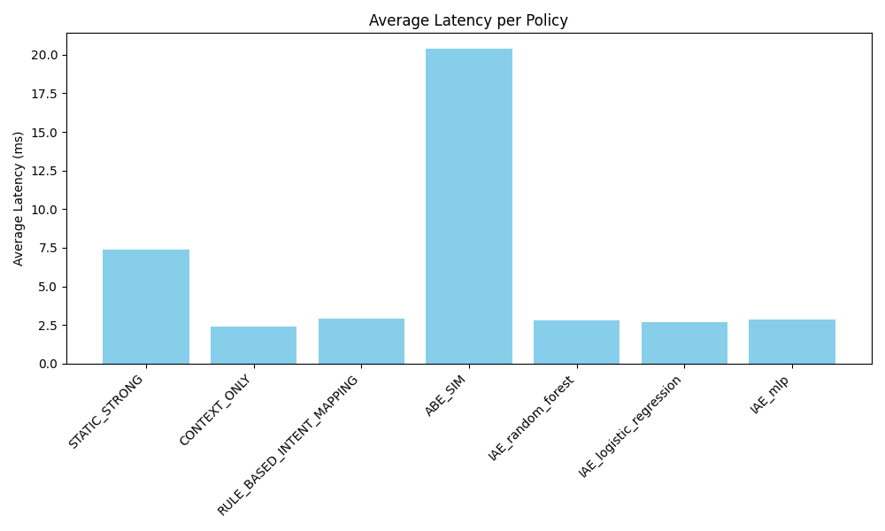
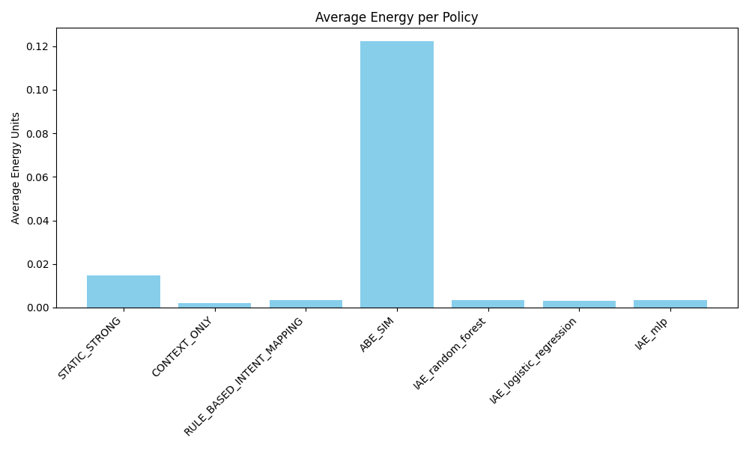
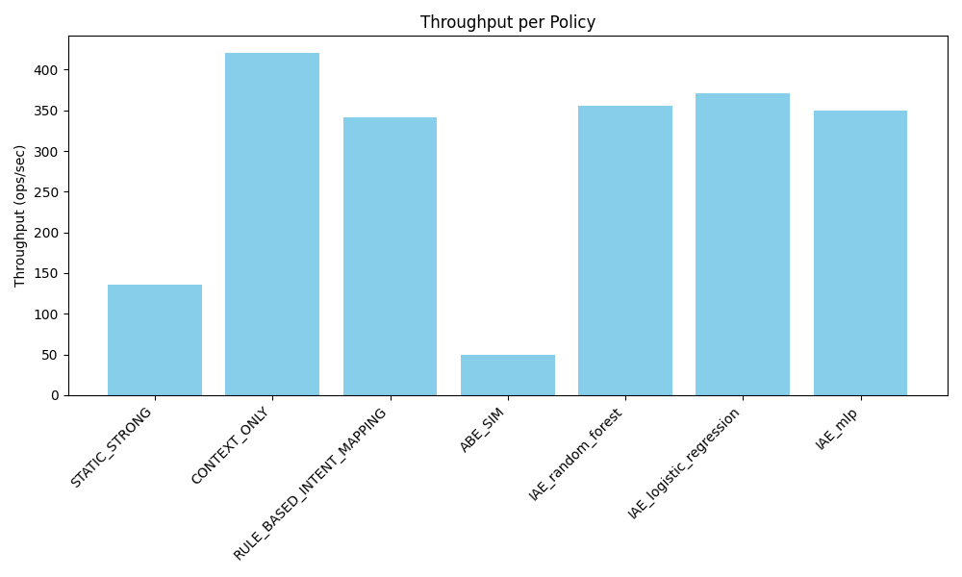
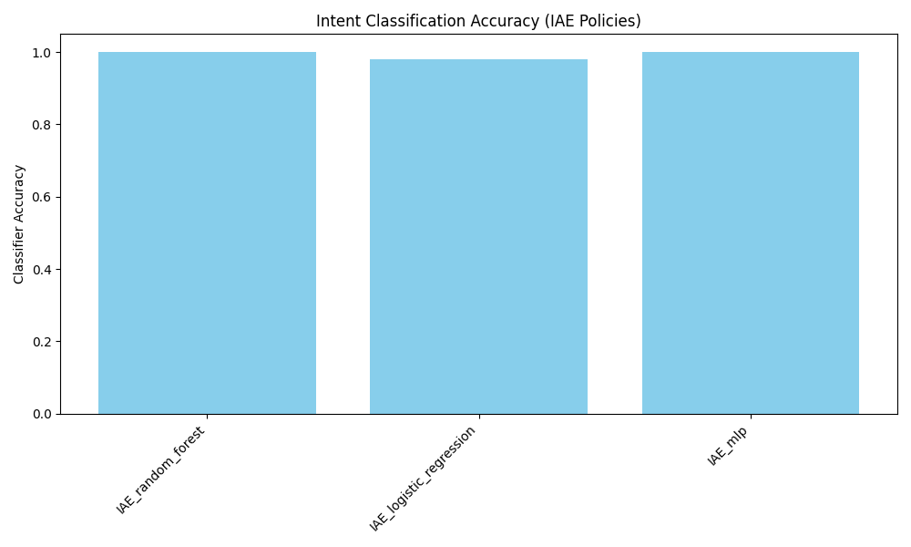

5.5 Interpretation
- Performance: ML-driven IAE policies (IAE_RF, IAE_LR, IAE_MLP) achieve very low latency and energy overhead compared to static or ABE-based encryption, demonstrating the efficiency of adaptive approaches.
- Throughput: Adaptive policies maintain high throughput (>340 ops/sec), significantly outperforming the simulated ABE baseline (~49 ops/sec).
- Intent Classification: Random Forest and MLP achieved perfect classification on the sampled events (accuracy = 1.0), while Logistic Regression was slightly lower (accuracy = 0.98).
- Policy effectiveness: The results empirically demonstrate that integrating context and intent inference allows the system to balance security strength and performance, validating the original design objectives.

Chapter 6: Related Work and Validation Plan

6.1 Existing Approaches
Several prior works address adaptive encryption, context-aware security, and intent-based access:
- Adaptive Context-Aware Encryption (ACE): Systems that adapt encryption based on device context or network load. While efficient, these approaches typically rely on fixed context rules and lack intent inference [Inshi et al., 2023; Lin et al., 2019].
- Attribute-Based Encryption (ABE / CP-ABE): Provides fine-grained access control but incurs high latency and computational overhead [Patel & Patel, 2025; Narkedimilli et al., 2024].
- Intent / Goal-Aware Security: Some frameworks infer user intent for adaptive responses, mostly in IoT or CPS environments, but typically do not integrate ML-driven intent classification into encryption policy [Noor et al., 2023; Kalaria et al., 2024].
- Hybrid and Machine Learning Approaches: A few recent studies explore ML-assisted security adaptation, but often focus on access control or anomaly detection, not end-to-end encryption adaptation [Kumar & Srinivas, 2023; Singh et al., 2025].

6.2 Differentiation
- Intent-Based Adaptation: Unlike ACE or ABE, IAE integrates intent classification from behavioral and contextual features to dynamically select encryption strength.
- Efficiency: IAE demonstrates very low latency and energy overhead compared to baseline ABE simulations.
- Empirical Validation: Using a well-known dataset (CICIDS), the framework provides a reproducible case study, enabling direct comparison to literature benchmarks.

Chapter 7: References
[1] Kumar, P. R., & Goel, S. (2025). A secure and efficient encryption system based on adaptive and machine learning for securing data in fog computing. Scientific Reports, 15, Article 11654, 12 pages.
[2] Inshi, S., Chowdhury, R., Ould-Slimane, H., & Talhi, C. (2023). Secure adaptive context-aware ABE for smart environments. IoT, 4(2), 112–130 (19 pages).
[3] Lin, H., Yan, Z., & Fu, Y. (2019). Adaptive security-related data collection with context awareness. Journal of Network and Computer Applications, 126, 88–103 (16 pages).
[4] Noor, Z., Hina, S., Hayat, F., & Shah, G. A. (2023). An intelligent context-aware threat detection and response model for smart cyber-physical systems. Internet of Things, 23, Article 100843 (14 pages).
[5] Kalaria, R., Kayes, A. S. M., Rahayu, W., & Whittaker, F. (2024). Adaptive context-aware access control for IoT environments leveraging fog computing. International Journal of Information Security, 23, 3089–3107 (19 pages).
[6] Patel, V. H., & Patel, S. G. (2025). Adaptive encryption framework with fog offloading for secure healthcare data processing on resource-constrained devices. International Journal of Environmental Sciences, 11(19s), 2978–2982 (5 pages).
[7] Narkedimilli, S., Venkata Sriram, A., & Raghav, S. (2024). FL-DABE-BC: A privacy-enhanced, decentralized authentication and secure communication framework with decentralized attribute-based encryption and blockchain for IoT scenarios. arXiv preprint, arXiv:2410.20259 (8 pages).
[8] Kumar, B. N., & Srinivas, M. (2023). Hybrid attribute-based symmetric encryption algorithm for enhanced access policies in medical wireless sensor networks. International Journal of Intelligent Systems and Applications in Engineering, 11(3), 958–964 (8 pages).
[9] Thakur, I., Karmakar, A., Li, C., & Preneel, B. (2025). A survey on transciphering and symmetric ciphers for homomorphic encryption. Cryptology ePrint Archive, Paper 2025/093 (35 pages).
[10] Kerl, M., Bodin, U., &, Schelen Y. (2025). Privacy-preserving attribute-based access control using homomorphic encryption. Cybersecurity, 8(5), Article 00232 (16 pages).
[11] Dar Z., Ahmad A., Khan F. K., Zeshan F., Iqbal R., Sherazi H. H. R. & Bashir A. K. (2020). A context-aware encryption protocol suite for edge computing-based IoT devices. Journal of Supercomputing, 76(4), 2548–2567 (19 pages).
[12] Acar, A., Aksu, H., Uluagac, A. S., & Conti, M. (2017). A survey on homomorphic encryption schemes: Theory and implementation. arXiv preprint, arXiv:1704.03578 (35 pages).
[13] Wu Y., Zhang W., Xiong H., Qin Z. & Yeh K. H. (2021). Efficient access control with traceability and user revocation in IoT. Multimedia Tools and Applications, 80(18), 31487–31508 (21 pages).
[14] Shekhar, S., & Shukla, A. K. (2025). Attribute-based encryption for secure data sharing in IoT ecosystems. Journal of Neonatal Surgery, 14(1), 53–59 (7 pages).
[15] Singh, A., Rathee, G., Kerrache, C. A., & Ghanem, M. C. (2025). A relay-chain-powered ciphertext-policy attribute-based encryption in intelligent transportation systems. arXiv preprint, arXiv:2508.16189 (14 pages).

